Two actor

Admin

Sign In (Sign Up) hard coding username and password.

Dashboard

Admin can do set of operations.

Customer/ user / Manager etc

Sign In and Sign Up

After Account created customer can login that application

Customer can do set of operation base upon customer, user etc

Backend : Spring boot

Database : mysql

Frontend : angular

Spring boot application using Spring interilizer

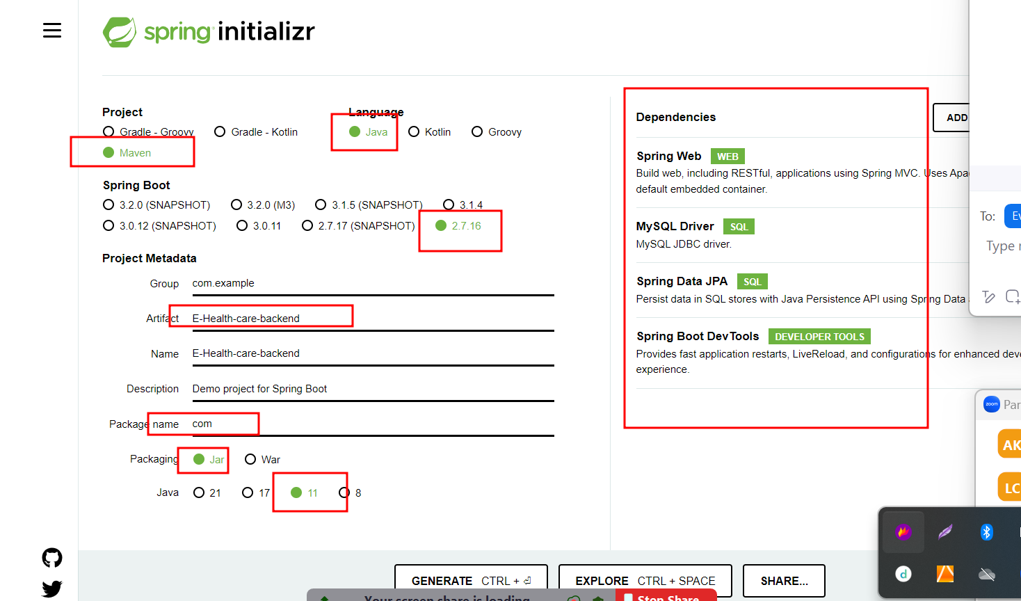

Create login rest api for customer and admin

Ie SignIn and SignUp

Now we will create front end for eheathcareapp